1.The average of first 10 even numbers is?

package Assignment_3_2;

import java.util.Scanner;

public class que_1 {

    public static void main(String[] args) {

        Scanner sc = new Scanner(System.in);

        int ave = 0;

        System.out.println("Enter the Number");

        int sum = 0;

        int a = sc.nextInt();

        for (int i = 0; i <= a; i = i + 2) {

            sum = sum + i;

            ave = sum / (a);

            System.out.println(i);

        }

        System.out.println(sum);

        System.out.println(ave);

    }

}

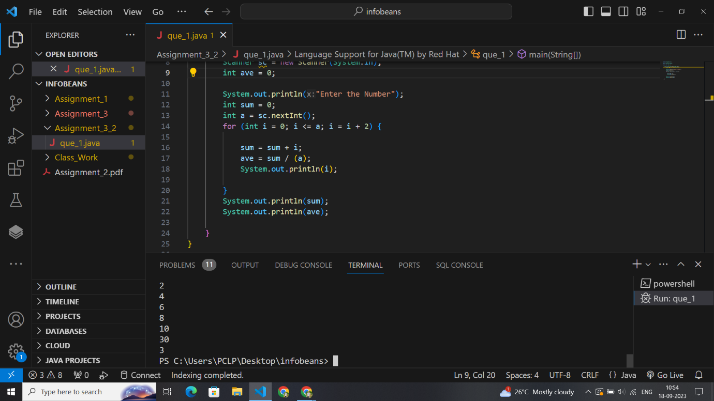

2.The average of 11 numbers is 10.9. If the average of first six is 10.5 and that

of the last six is 11.4 the sixth number is?

package Assignment_3_2;

public class que_2 {

    public static void main(String[] args) {

        double ave_11_num = 10.9 * 11, ave_f6 = 10.5 * 6, ave_l6 = 11.4 * 6;

        System.out.println(ave_11_num);

        System.out.println(ave_f6);

        System.out.println(ave_l6);

        double sixth_nm = (ave_f6 + ave_l6) - ave_11_num;

        System.out.println("sixth number is: " + sixth_nm);

    }

}

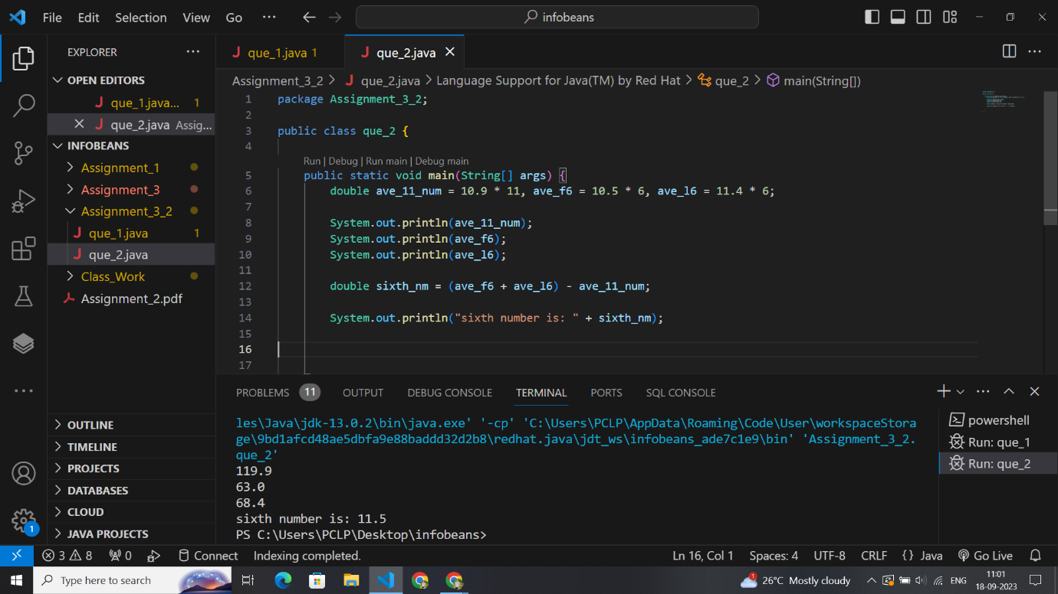

3.The average of first 10 natural numbers is?

package Assignment_3_2;

import java.util.Scanner;

public class que_3 {

    public static void main(String[] args) {

        Scanner sc = new Scanner(System.in);

        System.out.println("Enter number");

        int a = sc.nextInt();

        for (int i = 0; i <= a; i++) {

            System.out.println(i);

        }

    }

}

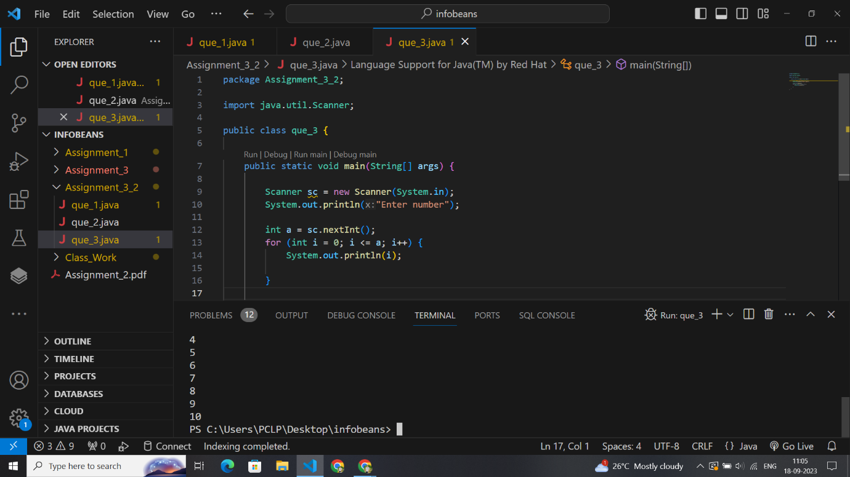

package Assignment_3_2;

public class que_4 {

    public static void main(String[] args) {

        int a = 3, b = 4, sum = 420;

        int c = a + b;

        int ave = sum / c;

        int d = ave * 3;

        System.out.println(" Smaller number :" + d);

    }

}

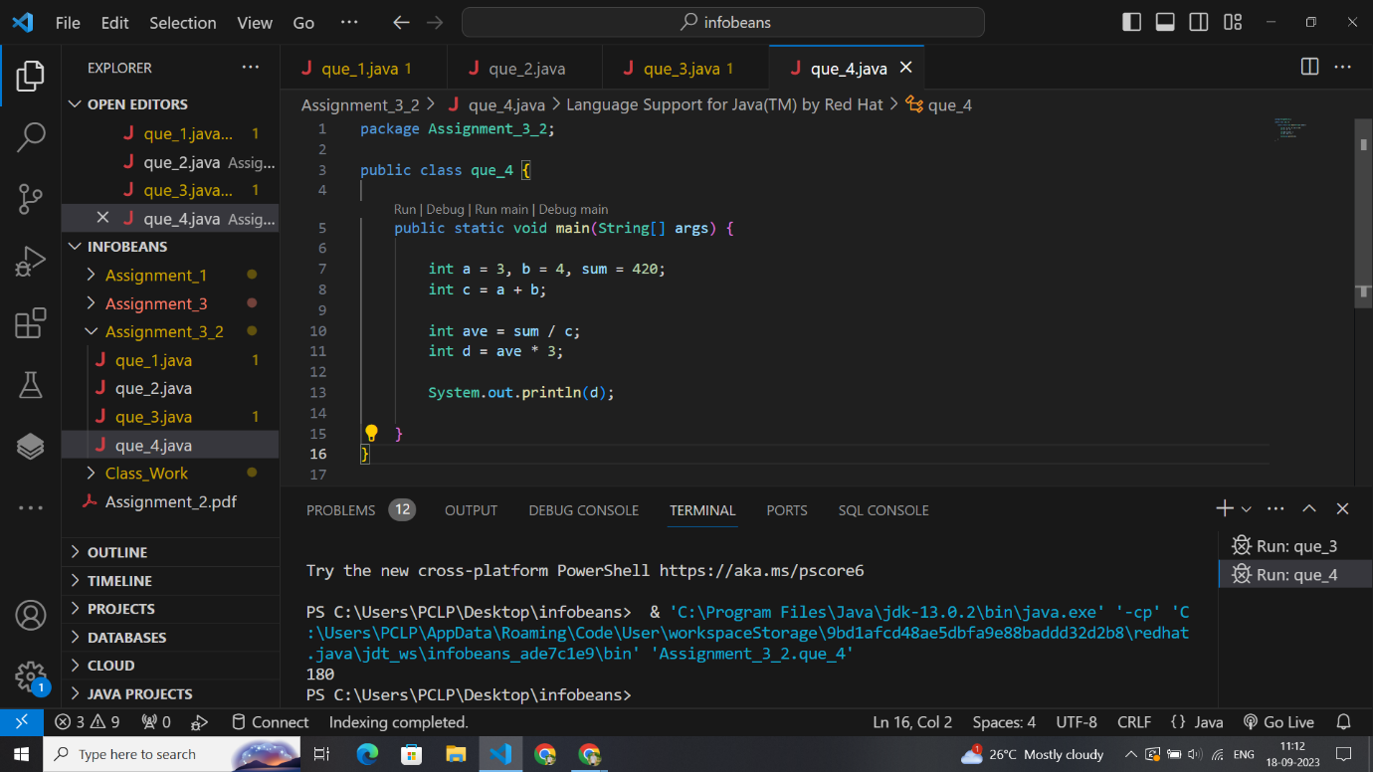

5.Sum of two numbers is 15. Two times of the first exceeds by 5 from the three

times of the other. Then the numbers will be?

package Assignment_3_2;

public class que_5 {

    public static void main(String[] args) {

        int x = 10, y = 5;

        int z = x + y;

        z = 15;

        // int a = (2 * x - 3*y) ;

        // int b = a-5;

        y = z - x;

        int a = 2 * x - 3 * (y);

        int b = a - 5;

        System.out.println(b);

    }

}

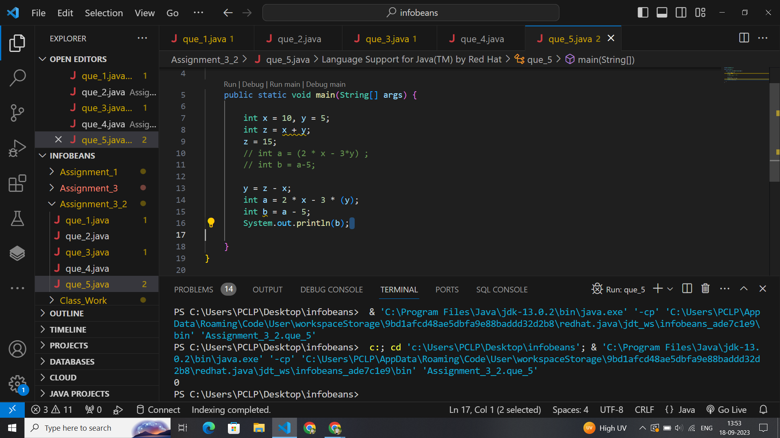

6.The length of the bridge, which a train 130 metres long and travelling at 45

km/hr can cross in 30 seconds, is:

package Assignment_3_2;

public class que_6 {

    public static void main(String[] args) {

        double lengthOfTrain = 130;

        double time = 30;

        double speedOfTrain = 12.5;

        //  speed =distance/time   d =(s*t)- total length of train

        // 45km/hr = 45*1000/3600 to change m/s = 12.5

        double length_bridge = (speedOfTrain * time) - lengthOfTrain;

        System.out.println(length_bridge);

    }

}

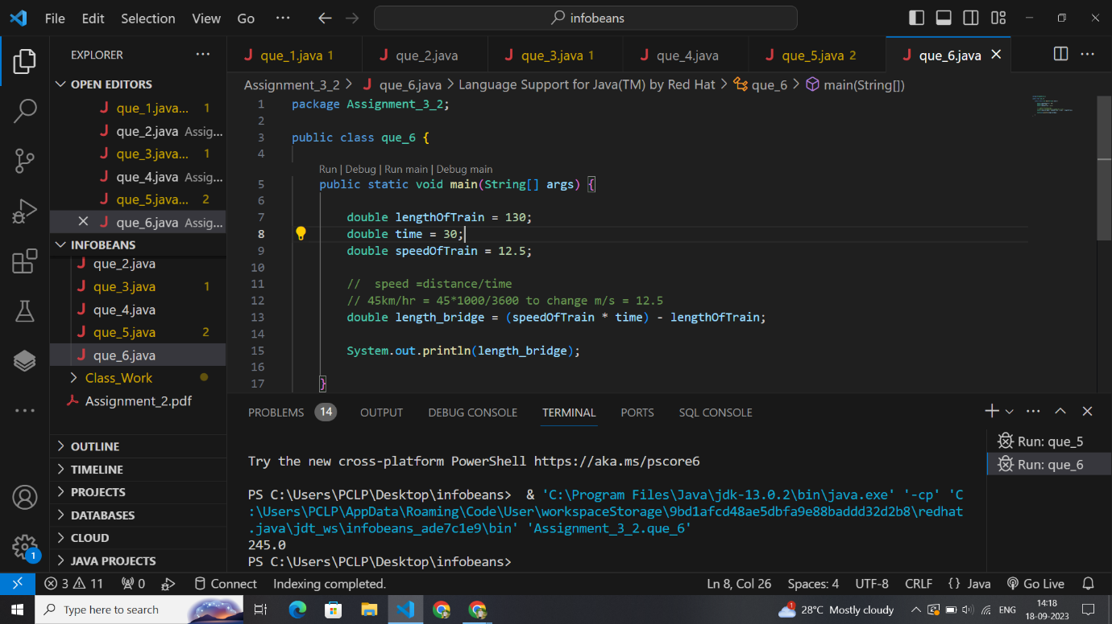

7. A train 125 m long passes a man, running at 5 km/hr in the same direction in

which the train is going, in 10 seconds. The speed of the train is:

package Assignment_3_2;

public class que_7 {

    public static void main(String[] args) {

        double lengthOfTrain = 125;

        double time = 10;

        // Man's Speed = 5 km/hr = (5 * 1000) / 3600 = 5/18 m/s

        // speedofman =d/time ,,, 5/18*10

        double speedOfman = (5 * 10) / 18;

        double speedOfTrain = (lengthOfTrain + speedOfman) / time;

        // Relative Speed = (LengthofTrain + speedofman) / Time

        System.out.println(" speed of train in : " + speedOfTrain + " meters");

    }

}

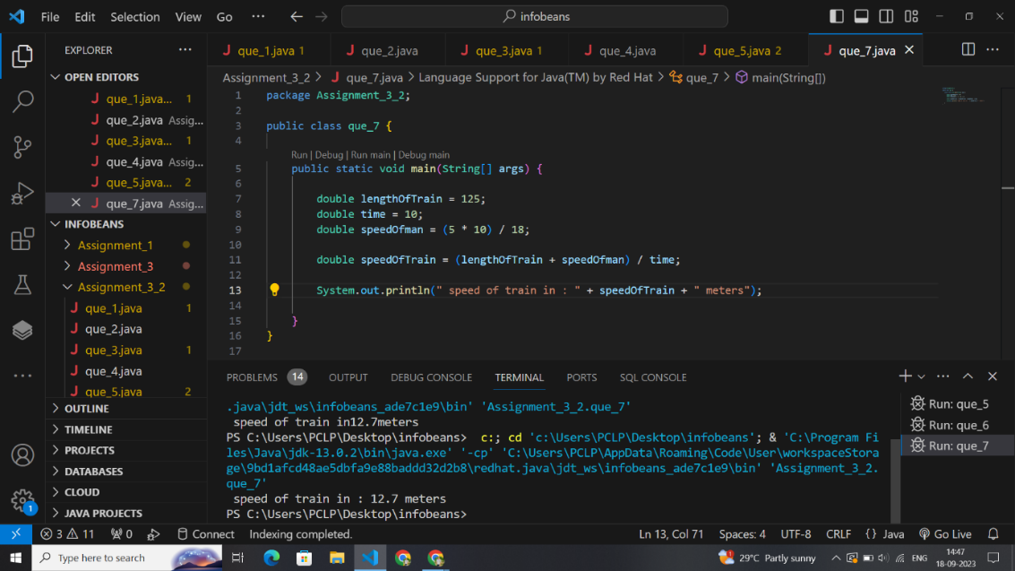

package Assignment_3_2;

public class que_9 {

    public static void main(String[] args) {

        int a = 26, b = 24, c = 10;

        int s = (a + b + c) / 2;

        double area = Math.sqrt(s * (s - a) * (s - b) * (s - c));

        System.out.println(s);

        System.out.println("area of triangle : " + area);

    }

}

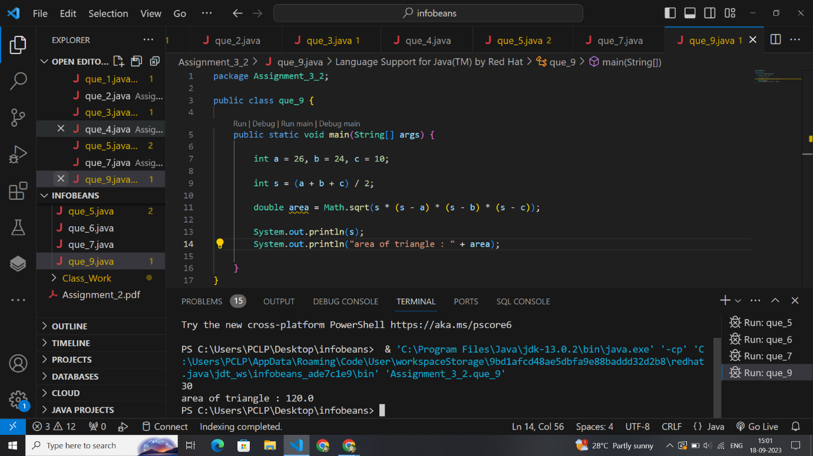

package Assignment_3_2;

public class que_10 {

    public static void main(String[] args) {

        int perimeter_of_triangle = 28;

        float inradius = 2.5f;

        float area = (inradius * perimeter_of_triangle) / 2f;

        System.out.println("Area of triangle : " + area);

    }

}

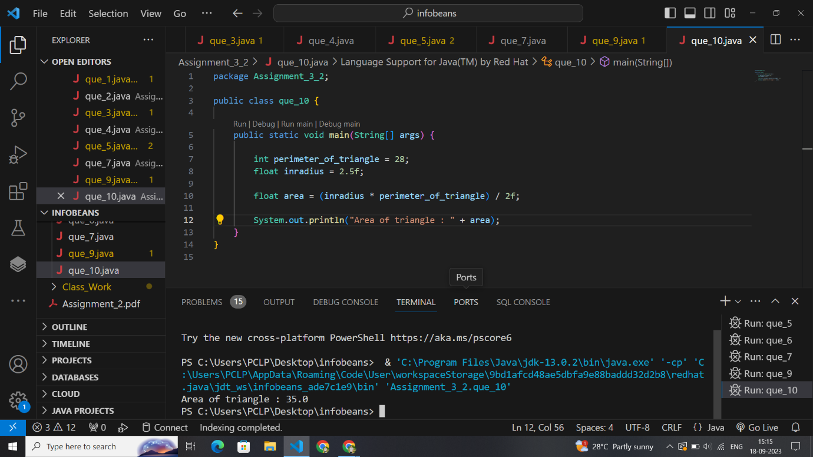

package Assignment_3_2;

public class que_11 {

    public static void main(String[] args) {

        double side1 = 20, side2 = 18, distance = 15;

        // area =a+b*h/2

        double area_of_trapezium = ((side1 + side2) * distance) / 2;

        System.out.println("area of trapezium : " + area_of_trapezium);

    }

}

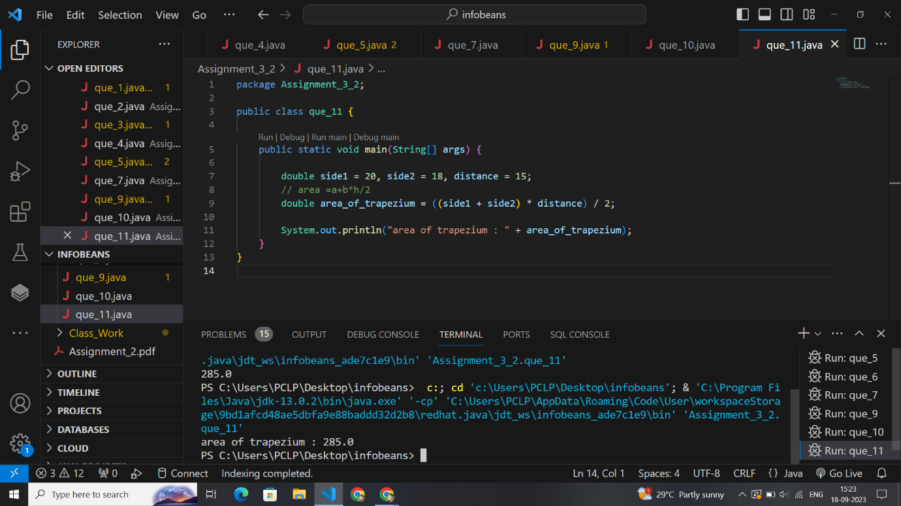

package Assignment_3_2;

public class que_12 {

    public static void main(String[] args) {

        int base = 24, height = 16, area;

        area = base * height;

        System.out.println("area of parallelogram : " + area);

    }

}

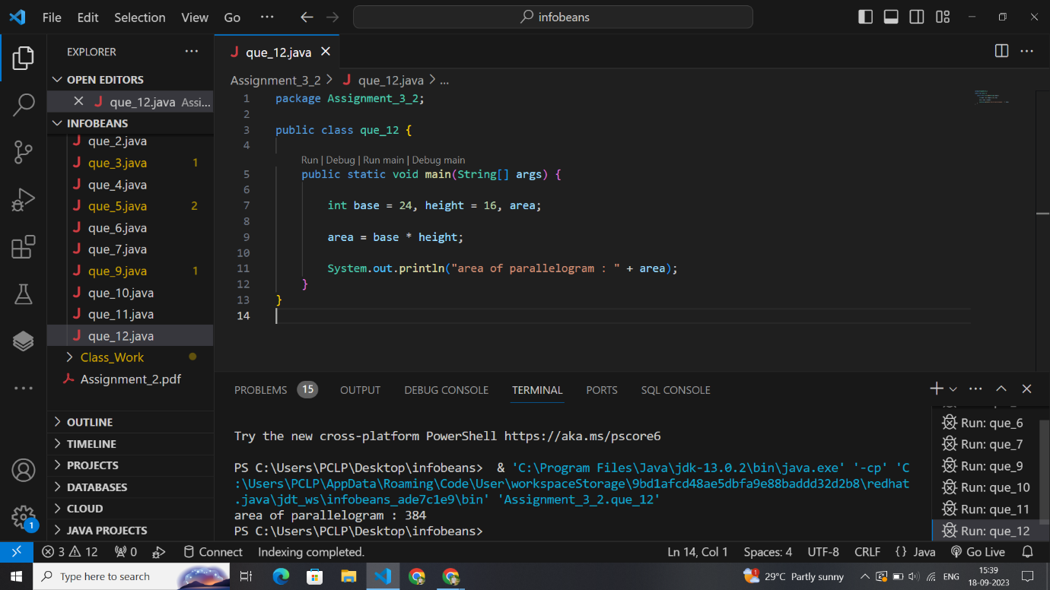

package Assignment_3_2;

public class que_13 {

    public static void main(String[] args) {

        double breadth, area = 876;

        // double length = 3 * breadth;

        // area = 3 * breadth * breadth;

        breadth = Math.sqrt(area / 3);

        System.out.println("breadth of rectangulr plot :" + breadth);

    }

}

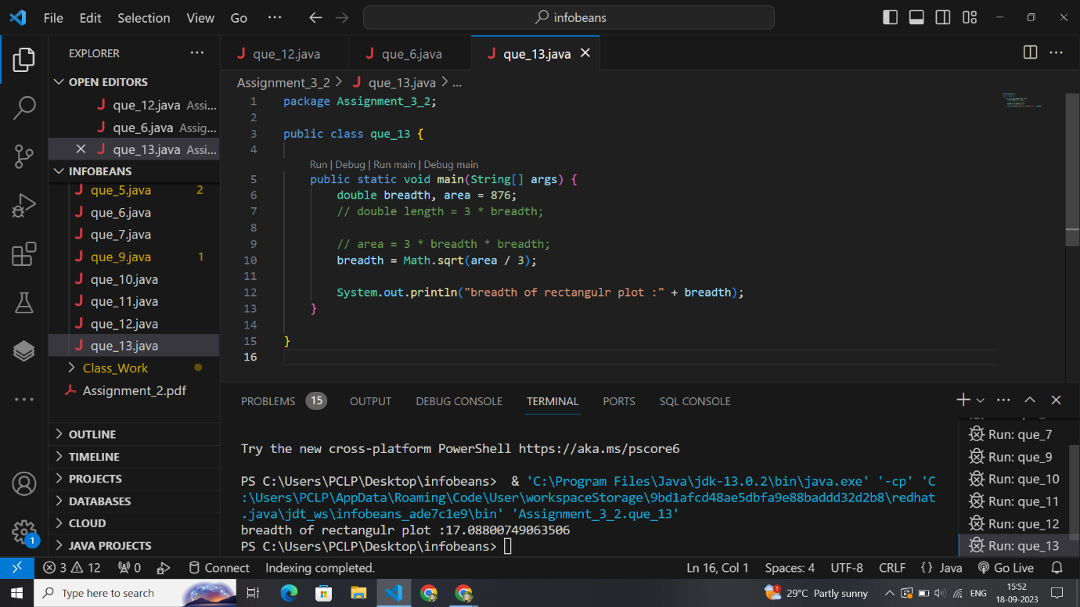

package Assignment_3_2;

public class que_16 {

    public static void main(String[] args) {

        double buying = 900, seling = 1080, profit, gain_per;

        profit = seling - buying;

        // Profit % = Profit/Cost Price × 100.

        gain_per = (profit / buying) * 100;

        System.out.println("Gain percentage :" + gain_per);

    }

}

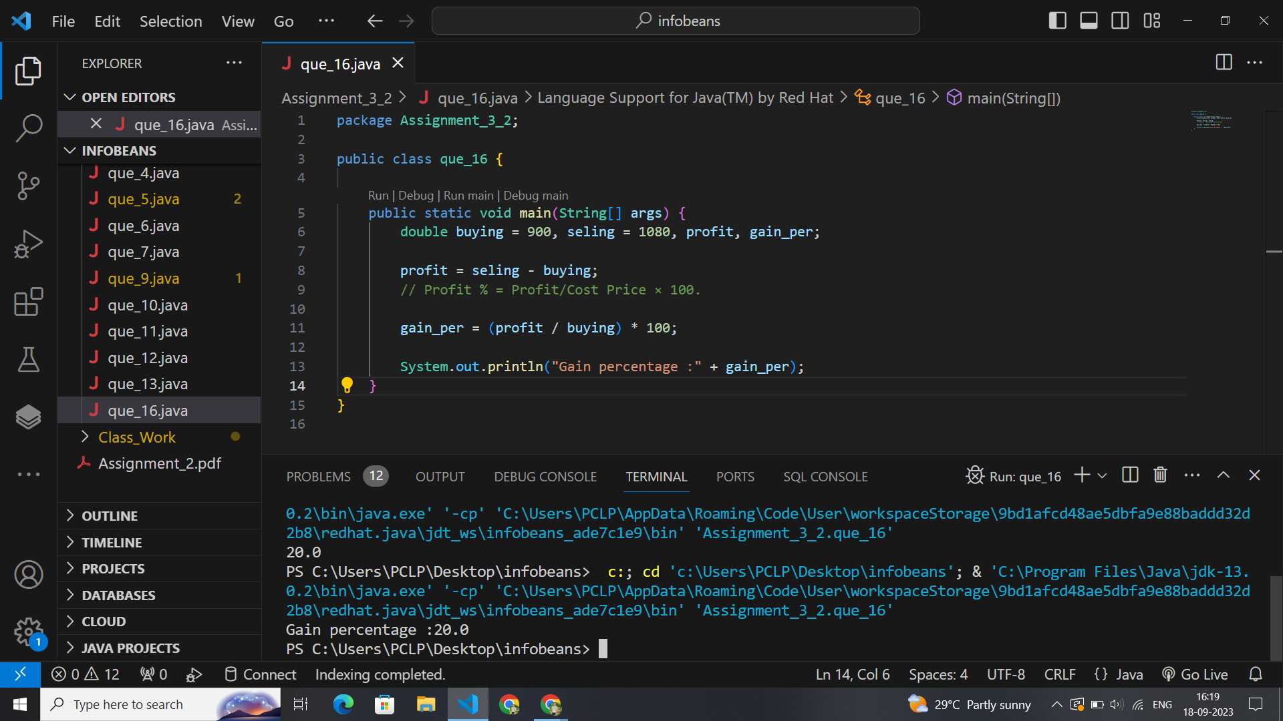

package Assignment_3_2;

public class que_17 {

    public static void main(String[] args) {

        double cost = 1500, sold = 1230, loss, loss_per;

        // loss

        loss = cost - sold;

        // loss per = loss/c.p*100

        loss_per = (loss / cost) * 100;

    }

}

package Assignment_3_2;

public class que_18 {

    public static void main(String[] args) {

        // volume of cube =a*a*a,,surface area of cube =6 a*a;

        double volume_cube = 1728, surface_area;

        double sideLength = Math.cbrt(volume_cube);

        surface_area = 6 * Math.pow(sideLength, 2);

        System.out.println("Surface area of cube :" + surface_area);

    }

}

package Assignment_3_2;

public class que_19 {

    public static void main(String[] args) {

        int l = 4, b = 5, h = 6, surface_area;

        surface_area = 2 * (l * b + b * h + h * l);

        System.out.println("Surface area of cuboid : "+surface_area);

    }

}

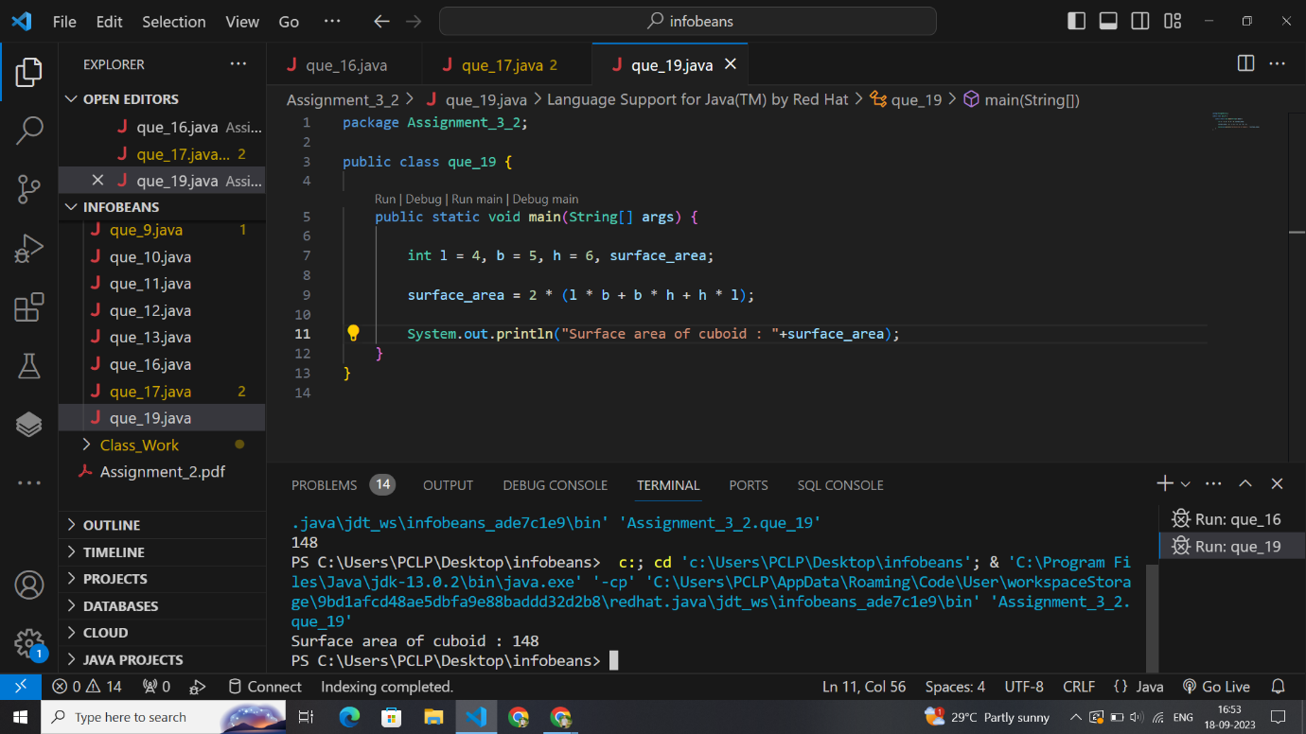

package Assignment_3_2;

public class que_20 {

    public static void main(String[] args) {

        int l = 4, b = 5, h = 6, volume;

        volume = l * b * h;

        System.out.println("Volume of cuboid : " + volume);

    }

}

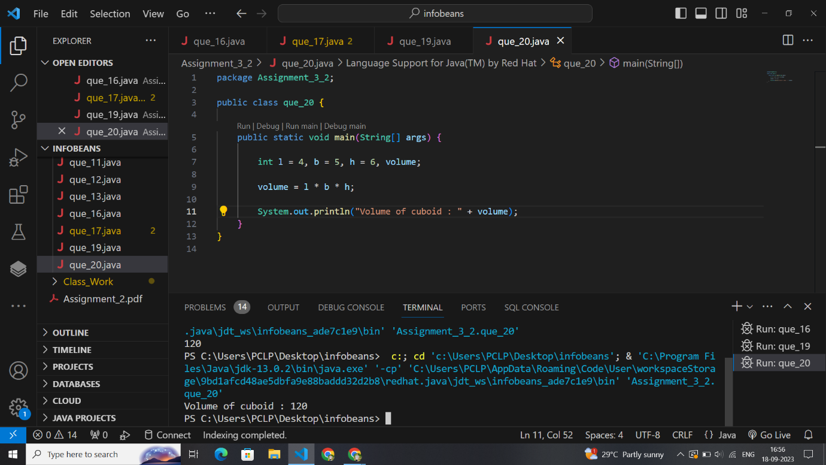

package Assignment_3_2;

public class que_21 {

    public static void main(String[] args) {

        // h =2*a/b

        int base = 40, area = 400, height;

        height = 2 * (area / base);

        System.out.println("Height of a triangle : " + height);

    }

}

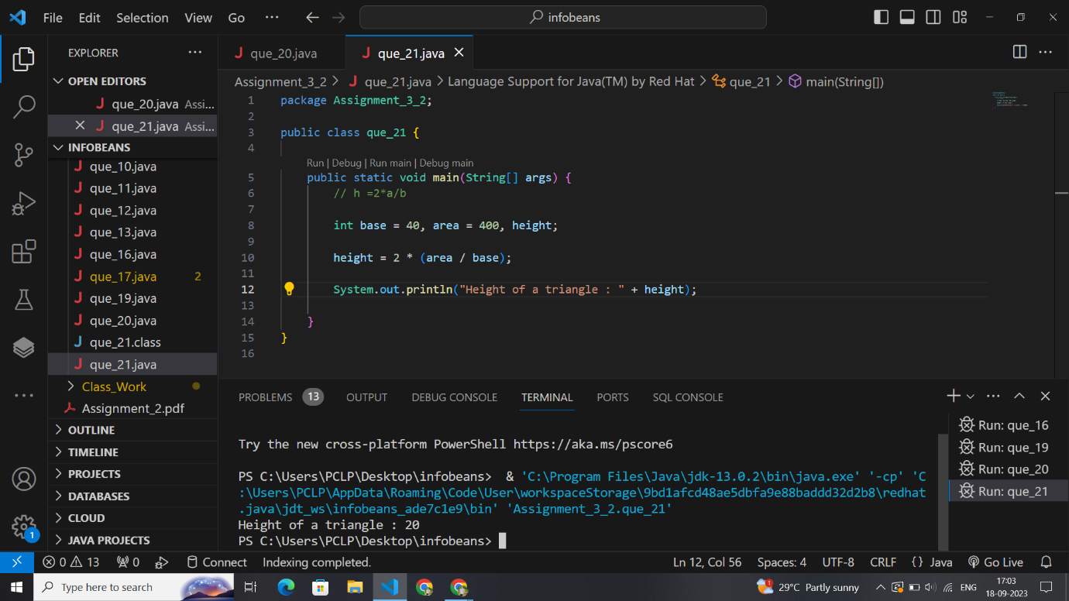

package Assignment_3_2;

public class que_22 {

    public static void main(String[] args) {

        int base = 4, height = 5, area;

        // a =b*h/2

        area = (base * height) / 2;

        System.out.println("Area of triangle :" + area);

    }

}

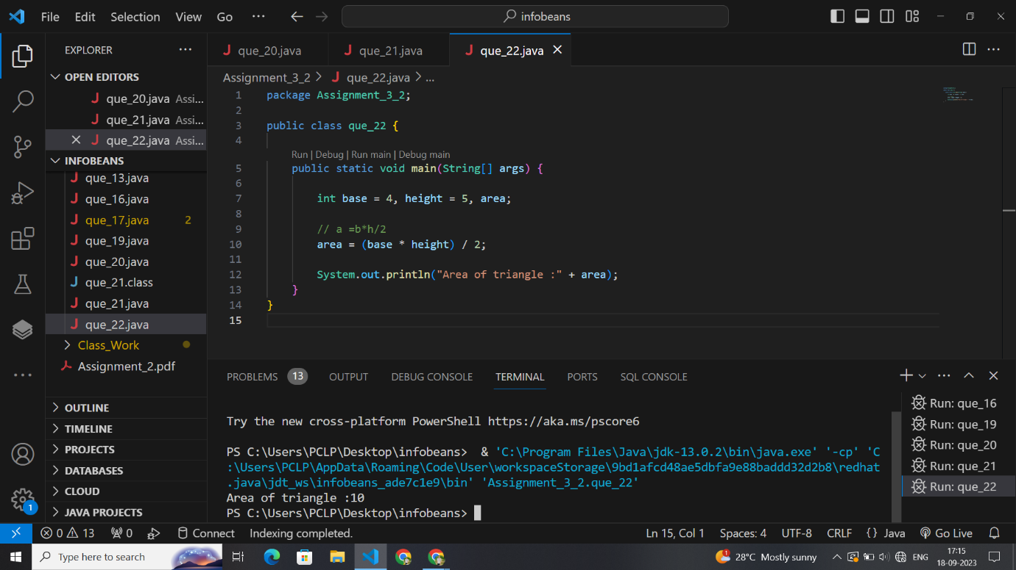

package Assignment_3_2;

public class que_23 {

    public static void main(String[] args) {

        double a = 1, b = 2, c = 3, area1;

        double s = (a + b + c) / 2;

        area1 = Math.sqrt(s * (s - a) * (s - b) * (s - c));

        System.out.println(s);

        System.out.println("area of triangle : " + area1);

    }}

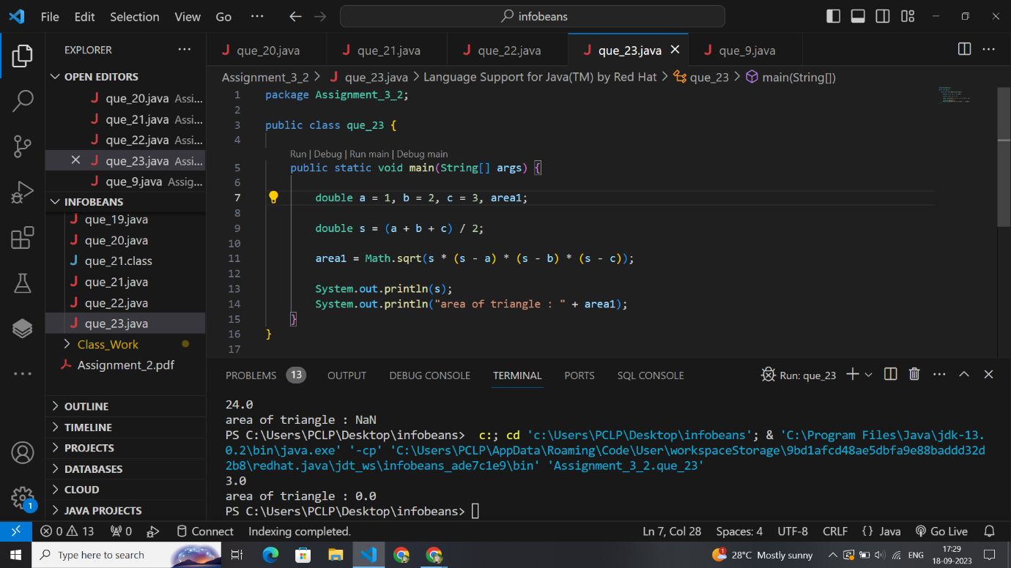

package Assignment_3_2;

public class que_24 {

    public static void main(String[] args) {

        // Base² + height² = hypotenuse²

        // Area of triangle = 1/2 × base × height

        double base = 8, hypotenuse = 10, area, heigth;

        heigth = Math.sqrt(hypotenuse * hypotenuse - base * base);

        area = (base * heigth) / 2;

        System.out.println("Height of triangle :" + heigth);

        System.out.println("Area of right triangle : " + area);

    }

}

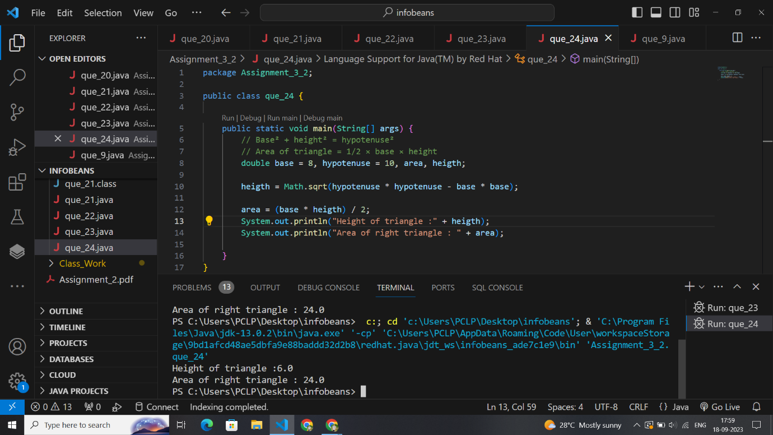

package Assignment_3_2;

public class que_25 {

    public static void main(String[] args) {

        // A=Math.sqrt 3/4a2

        double a = 12, area;

        area = Math.sqrt(3) / 4 * (a * a);

        System.out.println("Area of an equilateral triangle : " + area);

    }

}

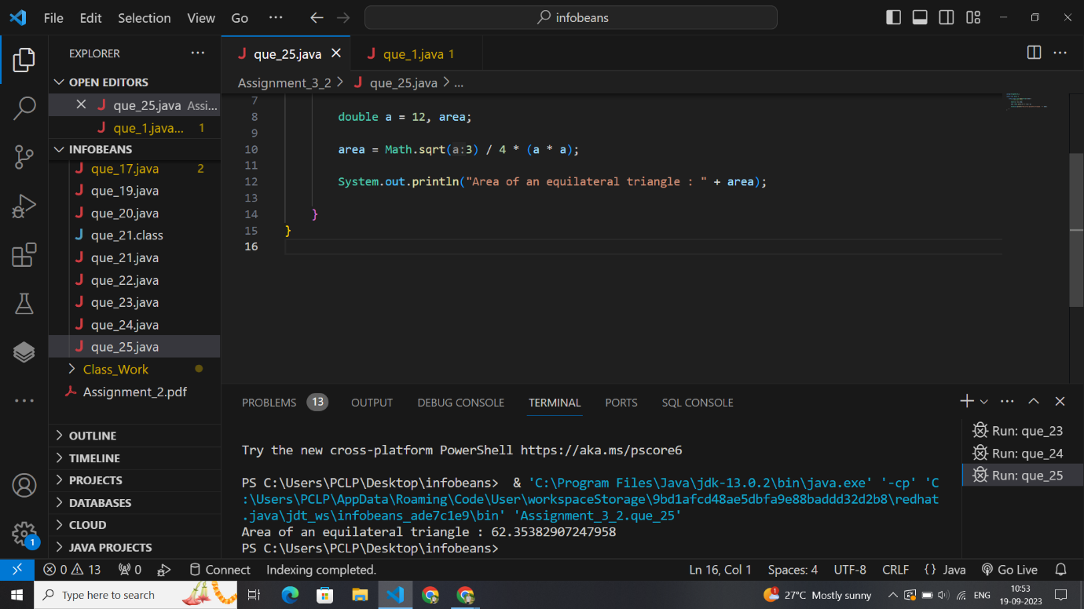

package Assignment_3_2;

public class que_26 {

    public static void main(String[] args) {

        int l = 30, b = 20, h = 8, volume;

        // Volume of a cuboid = l × b × h

        volume = l * b * h;

        System.out.println("Volume of cuboid:" + volume);

    }

}

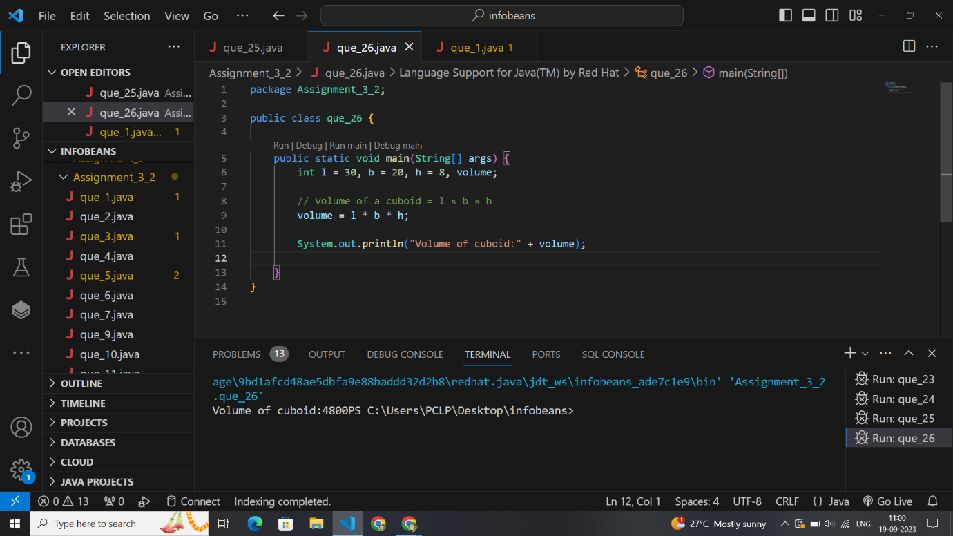

package Assignment_3_2;

public class que_27 {

    public static void main(String[] args) {

        double s1 = 125, s2 = 64, perimeter;

        //  5 times (area_square) = a*a,,, = area of reactangle

        // area of reactangle=l*b

        // perimeter of square =4a

        double area_square = 5 * (s1 * s2);

        double perimeter_square = 4 * Math.sqrt(area_square);

        // System.out.println("area of square :" + area_square);

        System.out.println("perimwter of square : " + perimeter_square);

    }

}

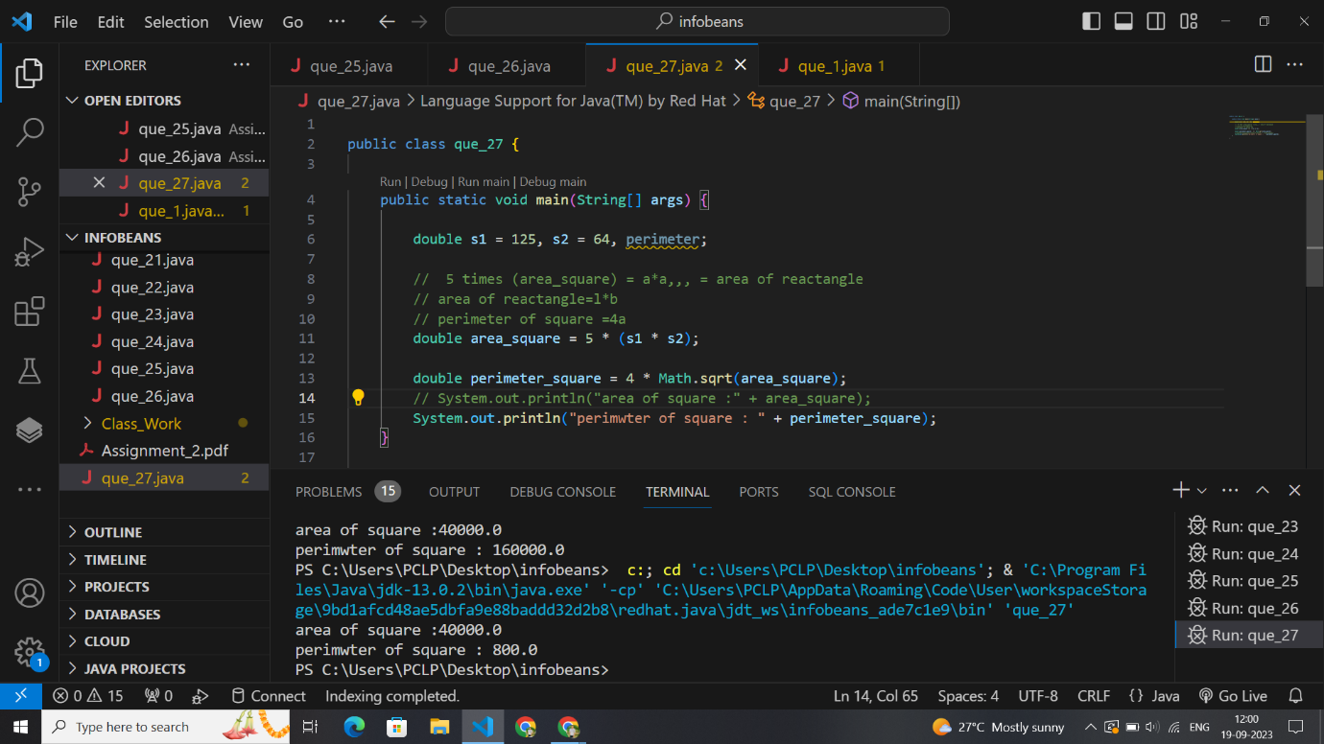

package Assignment_3_2;

public class que_40 {

    public static void main(String[] args) {

        // volume of cube =a*a*a;

        // volume of cube =N*volume of small cube

        int side_cube = 100, side_small_cube = 10, N;

        int volume_cube = side_cube * side_cube * side_cube;

        int volume_small_cube = side_small_cube * side_small_cube * side_small_cube;

        // volume_cube= N*volume_small_cube;

        N = volume_cube / volume_small_cube;

        System.out.println("total small cubes are obtained : " + N);

    }

}

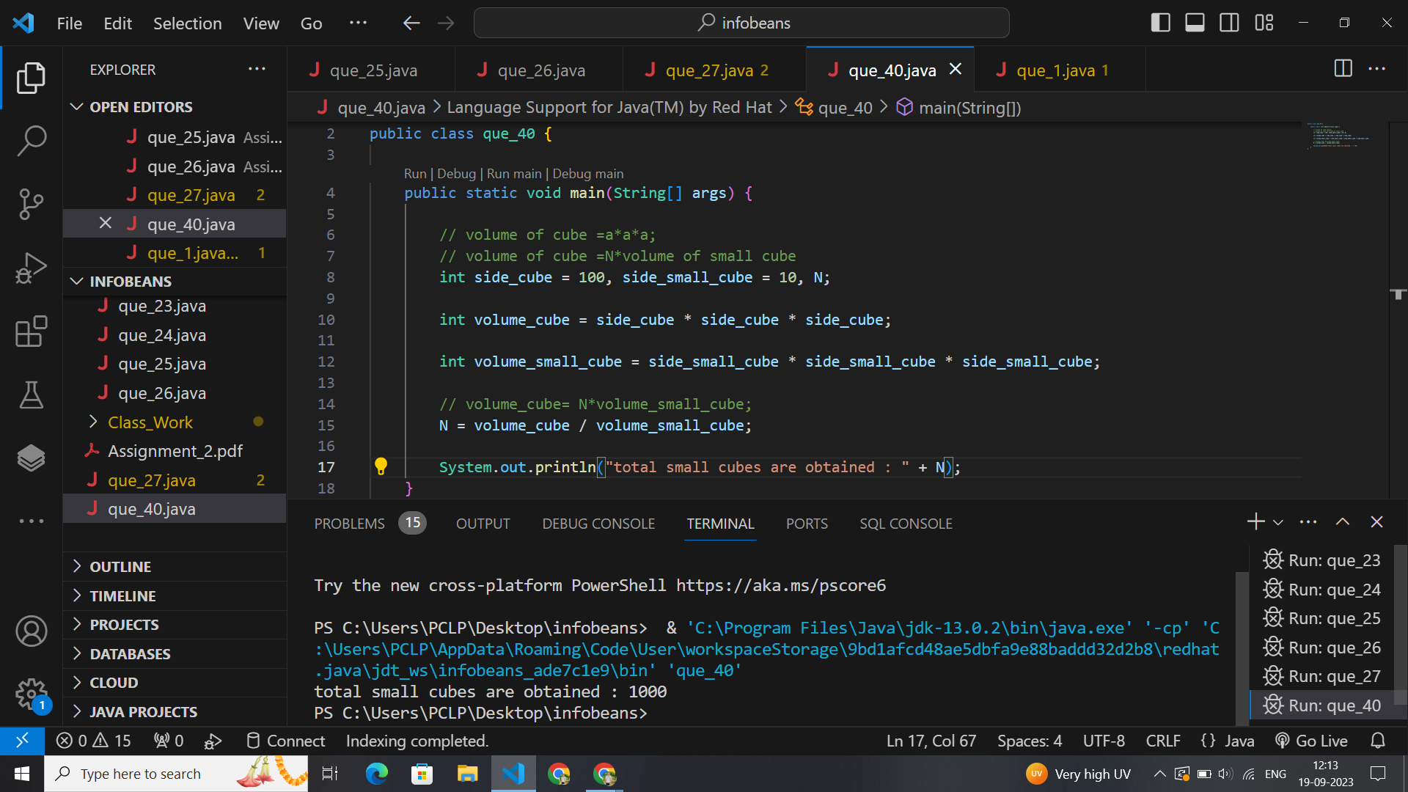

package Assignment_3_2;

public class que_41 {

    public static void main(String[] args) {

        int chair1 = 2, table1 = 3, total1 = 1300;

        int chair2 = 3, tables2 = 2, total2 = 1200;

        int final1 = chair1 + table1;

        int final2 = chair2 + tables2;

        int final3 = (final2) - (final1);

        int total = (total1) - (total2);

        System.out.println("chair : " + final3 + " total number of chairs are : " + total);

    }

}